Labwork 3

Task 2

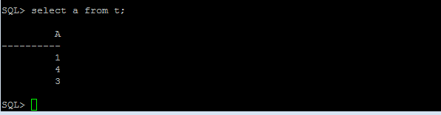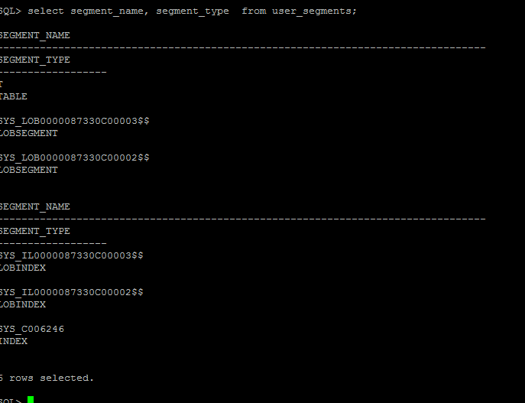

Task 3

Heap Table

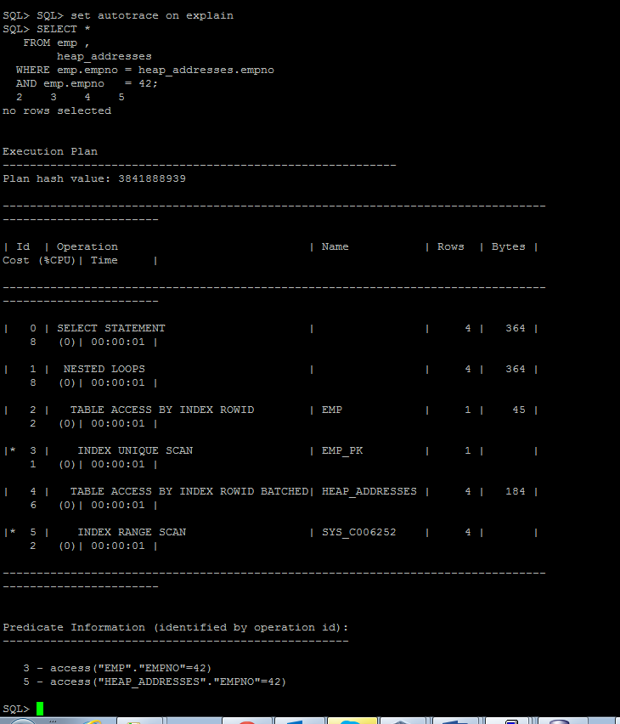

Index Organized Table

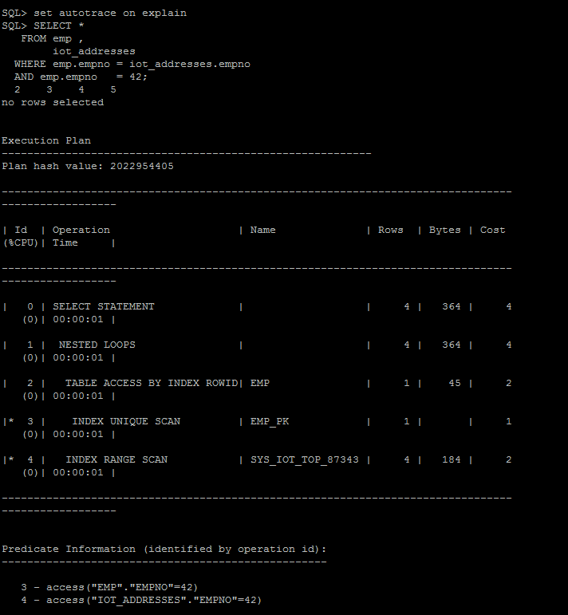

IOT contains not only indexed columns but also all rows of the table. For IOT will be used primary keys. So you’re have all columns for result . HEAP search by rowid of your index to refer to the records of the table and then select an all columns that you need. So Heap-organized needs two operations (search and table access), when IOT only one(search).

Task 4

# Index Clustered Tables

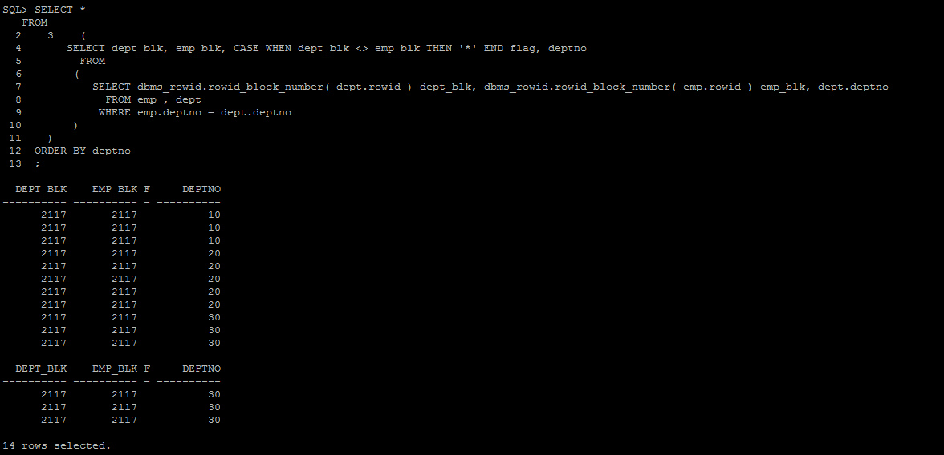

Index clustered tables: Clusters are groups of one or more tables, physically stored on the same database blocks. With a cluster, a single block of data may contain data from many tables. Conceptually, you are storing the data “prejoined.” It can also be used with single tables where you are storing data together grouped by some column.

Advantages: First, many tables may be stored physically joined together; Second, all data that contains the same cluster key value, such as DEPTNO = 10, will be physically stored together.

Task 5

# Hash Clustered Tables

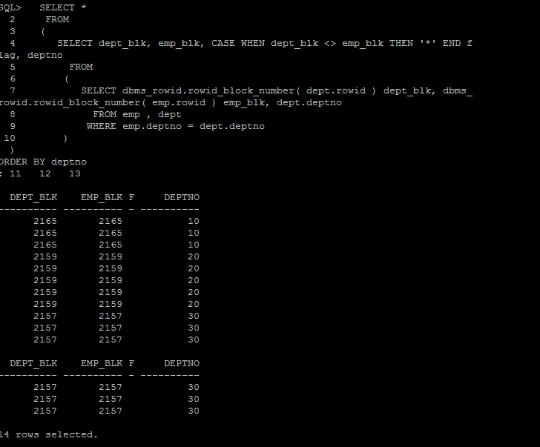

Hash clustered tables are very similar in concept to the index clustered tables just described with one main exception: the cluster key index is replaced with a hash function. Hash key values and a hash function distributed evenly over all of the blocks allocated to the hash cluster.